TECHNICAL & BUSINESS WRITING ASSIGNMENT#2



Assignment: Report Writing

Submitted By:

Hassan Anwar | BSEF12M014
Muzamil Ejaz | BSEF12M054
Hisham Zahid | BSEF12M025
Badar Iqbal | BSEF12M038
Raza Ahmed | BSEF12M061

Submitted to:

Sir Tahir Sarwar

The Education System
in Pakistan

The Education System
in Pakistan

Prepared for:
Professor Tahir Sarwar
Lecturer
PUCIT, Old Campus, Lahore

Prepared by:
Hassan Anwar
Muzamil Ejaz
Hisham Zahid
Raza Ahmed
Badar Iqbal

January 04, 2016

PUNJAB UNIVERSITY COLLEGE OF IT
The Mall
University of the Punjab
Lahore, Pakistan

January 4, 2016

Professor Tahir Sarwar,
Lecturer,
Punjab University College of Information Technology,
The Mall,
University of the Punjab,
Lahore.

Respected Professor Tahir,

Here is a detailed report on education system of Pakistan which was conducted, on your demand, on December 31, 2015. The National Education Census (NEC) of 2005/06 was the first education census conducted in the history of Pakistan that was specifically designed to collect information on all types of schools. It thus generated a complete and comprehensive picture of the current education system in the country, and provides a robust information baseline from which to measure future progress.

This report can be very beneficial for assisting other education data collection activities in the field.

Yours sincerely

Hassan Anwar

Enclosed:- Find the attachment of our report.

TABLE OF CONTENTS:

EXECUTIVE SUMMARY | 1
Introduction | 3
Chapter 1: Capacity & Participation Issues in Pakistan's Education System | 5
Chapter 2: School Administration | 7
Chapter 3: Girls Education | 10
Chapter 4: Teaching Posts & Teacher Training | 13
BIBLEOGRAPHY | 16

Executive Summary

This is the complete and comprehensive picture of the current education system in the Pakistan, and provides a robust information baseline from which to measure future progress. Through ensuring a complete listing of schools, it also assists other education data collection activities in the field.
Pakistan also has a National Education Management Information System (NEMIS) which collects education data annually. The system covers public education sector, but to date has not comprehensively covered private sector educational provision. Since some 31% of basic education students attend private schools, it is therefore important that up-to-date information be made available on this sub-sector, to ensure that policy development is based on knowledge of the entire education system not just the public sector.

The NEC (National Education Census) provides a snapshot of current conditions in education (including in the private sector), but it does not
show whether conditions are improving or deteriorating over time. In order to answer such questions, similar data has to be obtained on a regular basis on both public and private schools.

A combination of the NEC and the NEMIS shows that over 36 million students were attending an educational institution in 2005/06. Just under 50% of those students (17.8 million) were studying at the primary level, 20.9% (7.5 million) in pre-primary, 15.4% (5.6 million) in middle elementary, 6.9% (2.5 million) in secondary, 2.5% (.9 million) in higher secondary and 4.9% (1.8 million) at the postsecondary level.

It is clear that Pakistan is still a long way from achieving universal primary enrolment. As indicated 1 by the primary Net Enrolment Rate (NER)'s estimate of 62% , over 35% of the population 5 to 9 years of age is not in school Given a population of 5 to 9 years old of some 19.5 million, this means that about 7 million children aged 5 to 9 are out of the education system.

In Pakistan, there were 14 million girls studying in basic education in 2005, compared to 18.3 million boys. In other words, there were over 4 million more boys than girls in basic education, which results in a Gender Parity Index (GPI) of .76. This disparity in favors of boys was prevalent at all levels of basic education, with the exception of the higher secondary level, where there was parity between the sexes, producing a GPI of 1.0. In Pakistan, because there are more boys than girls in the relevant population, this represents a small disparity in favors of girls. This level of GPI at the higher secondary level shows that many more boys than girls discontinued their education after secondary school, with the result that their numbers matched those of the girls in the final level.

Analysis of the report shows that many schools are in need of better facilities to improve the teaching environment. For example, 9% of primary schools do not have a blackboard, 24% do not have textbooks available for the children and 46% do not have desks for the students. Private primary schools are better equipped with desks and blackboards, but almost one-

quarter of primary schools in both the public and private sectors do not have any textbooks. Only 36% of the public primary schools in the country
have electricity, though the picture improves further up the educational ladder, with most middle elementary, secondary and higher secondary schools having access to electricity.

Introduction

This report describes Pakistan's education system through a series of highlights drawn mainly from published data released by the Academy of Education Planning and Management. The data used were taken primarily from the National Education Census (NEC) conducted in 2005/06, and the National Education Management Information System (NEMIS), 2005/06. The NEC was the first such survey conducted in the history of Pakistan and it provides a comprehensive view of the education system covering all educational institutions. Where possible, data were included from the 2007 publication Pakistan Education Statistics 2005-2006, to ensure that this paper reflects the latest available statistical information. The data are used to calculate internationally recognized education indicators and to draw comparisons with selected other countries, to help benchmark the system's characteristics. The present paper makes extensive use of charts to communicate information on the particular facet of education under review.

The report is divided into five chapters that concentrate on the basic education levels. Chapter 1 examines at the capacity and participation in the education system. Data are reviewed by level (stage) of education and by province. Chapter 2 looks at school administration - the degree to which the system depends on public and private institutions; and determines locational where (urban, rural) and at what levels of education private schools predominate. Chapter 3 assesses the system's progress towards achieving gender parity. Chapter 4 reviews NEC data on teaching posts and teacher training, because the need to fill vacant teaching positions and to provide training for untrained teachers will directly affect future education budget.

The report examines education indicators from selected other countries from adjacent countries (Iran, India), and from the South Asian region (Sri Lanka, Indonesia, Philippines, Vietnam). A random selection (based on data availability) of comparator countries (Nigeria, Egypt) has also been used. To enable the reader to determine their appropriateness for comparison with Pakistan, the Gross National Income (GNI) per Capita (GNI converted to $US using the World Bank atlas method divided by mid-year population estimates) and the population are provided for the selected countries in the Table 1.

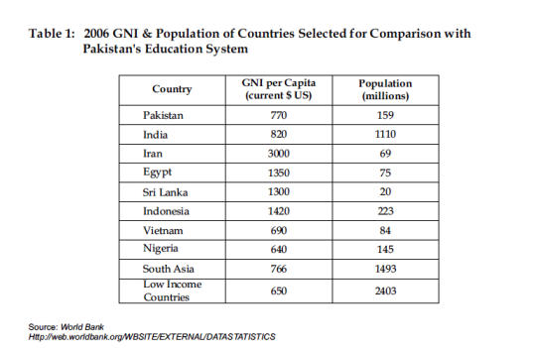

Chapter 1: Capacity & Participation Issues
in Pakistan's Education System

NEC/NEMIS data show that Pakistan's education system focuses strongly on primary education. Despite this concentration, however, there are still many children between 5 to 9 years of age that are not attending school and it would appear that the primary system needs to expand if universal primary enrolment is to be achieved. Other countries reviewed have

significantly larger proportions of children of primary age in their primary education programs. At the same time, the system's ability to accommodate students who wish to continue their education beyond the primary level is relatively low, which has both economic and social implications for Pakistan's future. Balancing growth at the primary level with growth at the higher levels of education should be a priority.

In 2005/06, Pakistan's education system accommodated over 36 million students. Of these, 95% (34 million) were studying at basic education levels, pre-primary through higher secondary.

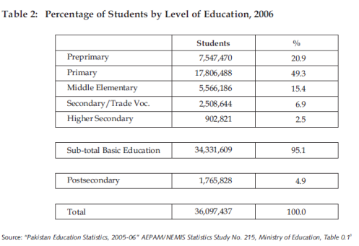

Information on the flow of students from grade to grade and from one level of education to the next (transition rate) is required to accurately reflect the relationship between each of the levels of education. In the absence of these measures, the average number of student places for each grade was used a measure of the capacity of the education system at each level. As primary education has a current capacity of just over 17.8 million students, it can accommodate an average of 3.6 million for each grade/year (17.8 million student places divided by the 5 grades of primary school) under existing conditions (number of teachers, current class sizes, school facilities, etc.). Of course, enrolment is not always divided in this way, as the lower grades

may have more students and the higher, less students. However, it does indicate the overall capacity to accommodate primary students. By comparison, pre-primary education can accommodate an average of over 3.8 million, middle elementary 1.9 million, secondary 1.3 million and higher secondary 451,000 students.

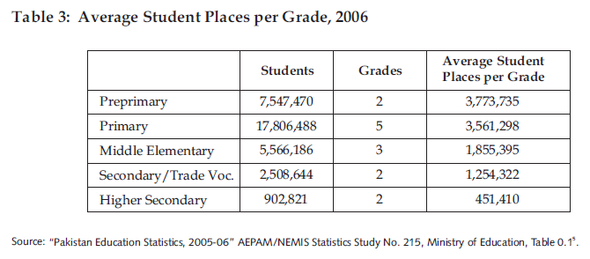

Other countries provide greater opportunities for students to proceed beyond primary level education. Using the ISCED classification of levels, it is possible to compare the percentage of lower secondary student places (middle elementary and secondary for Pakistan) to primary student places per grade. In fact, both Sri Lanka and Iran provide as many student places

per grade at the lower secondary level as they do at the primary level. Pakistan's percentage is much lower (46%) than all of the selected comparator countries: see Chart 3.

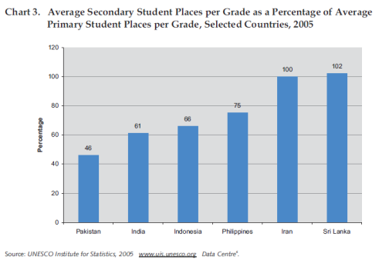

Chapter 2: School Administration

The degree to which education systems rely on private education institutions (i.e., those controlled and managed by non-governmental organizations, such as a religious body, trade union or business enterprise) varies considerably from country to country. This ranges from systems where all education institutions are public (institutions controlled and managed by a public education authority or a government agency), to others where a combination of public and private institutions share the responsibility of teaching children. Where private providers play an important role in the education system, they may or may not receive public funding; and they may or may not be required to meet certain standards such as the provision of a set curriculum or the professional and academic training requirements for their teaching staff. Pakistan is an example of a country that has both public and private sector educational institutions, which has a larger proportion of its youth attending private institutions than in many other countries. As a result, it is important for Pakistan to obtain comprehensive data from both of these types of schools on a regular basis,
to ensure that policy development is based on knowledge of the entire education system - not just for the public sector alone.

Private education institutions enroll 31% of students who are studying in basic education (preprimary through higher secondary). In urban centers, private schools account for more students (51%) than the public sector (49%). However, the situation is reversed in rural areas, where over 80% of students are attending public schools, as illustrated in Chart 9.

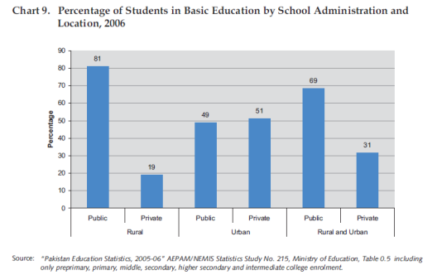

Private schools are most prevalent in FANA, where 4 out of every 10 basic education students attend private schools (41%). FATA and Baluchistan are at the other extreme, where over 80% of basic education is provided by the public sector, and where private education accounts for less than 20% of total provision.

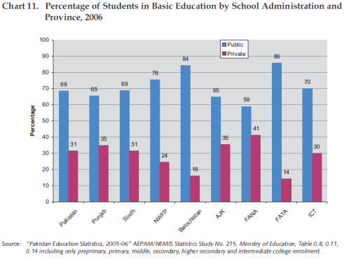

In comparison with other countries, private basic education in Pakistan enrolls more students than in most other countries. In fact, only 10 countries with relatively large populations in the world have a higher percentage of students in private primary education, led by The Netherlands (69%) and Lebanon (66%). Using the same countries as selected in Section 1, Chart 6, (where data were available) all show a lower percentage of students in private schools than in Pakistan: see Chart 12.

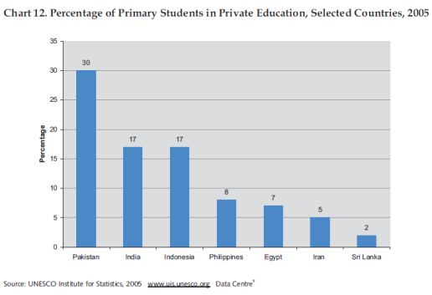

Chapter 3: Girls Education

The participation of female children in basic education has historically lagged behind that of their male counterparts in many countries. In the absence of data that could be used to calculate net enrolment rates by gender (enrolment by age and population by age), a measure that helps determine the extent of gender disparity is the Gender Parity Index (GPI). The GPI is defined as the ratio of females to males. A GPI of 1 generally indicates parity between the sexes. However, as Pakistan's school age population has a larger number of boys than girls, a GPI of approximately .95 would indicate that the percentage of girls and boys in school would be the same. A GPI of between 0 and 1 (in Pakistan between 0 and .95) means a disparity in favors of boys while a GPI greater than 1 (greater than .95) indicates a disparity in favors of girls.

In Pakistan, there were 14 million girls studying in basic education in 2006, compared to 18.3 million boys. In other words, there were over 4 million more boys than girls, resulting in a GPI of 0.76: see Chart 13, below. The disparity in favors of boys was prevalent at all levels of basic education, with the exception of the higher secondary level where the number of girls

was almost equal to the number of boys, indicating that Pakistan shows a disparity in favors of girls at this level of education. This implies that many more boys than girls discontinued their education after secondary school with the result that their numbers matched those of the girls in the final level.

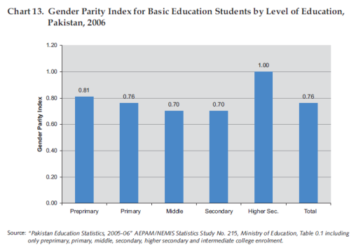

The GPI for primary education indicates that urban centers in the Punjab have a small disparity in favors of girls: see Chart 15. The ICT and AJK have small disparities in favors of boys both in urban and rural areas as does Sindh and FANA in their urban centers. The GPI in the rural areas of FATA show that less than half of the enrolment in primary education is female.

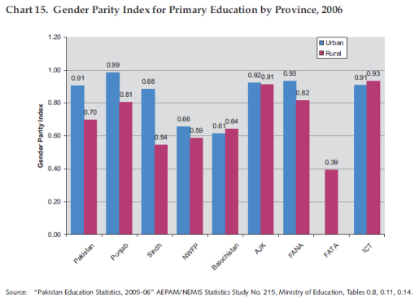

The participation of females in primary education compared to males is lower in Pakistan than in other selected countries. Most countries have GPIs around 0.9 - still a disparity in favors of boys – but to a lesser degree than in Pakistan. Iran, for example, has a disparity in favors of females with a GPI of 1.15: see Chart 16.

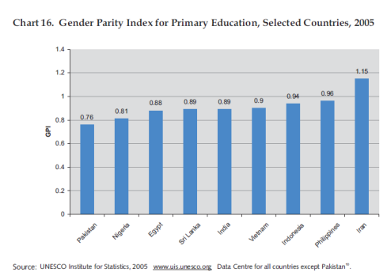

Chapter 4: Teaching Posts & Teacher Training

The NEC reports that there were 1.5 million teaching posts in the country, taking into account all levels and types of education. General education (pre-primary through higher secondary, intermediate and degree colleges, general university and the British system) accounts for 1.38 million (91%) of these teaching posts, with the other 9% employed in vocational, technical/professional and other schools.

The basic education level (pre-primary through higher secondary) has 1.3 million teaching posts. Of these, 90% were filled, 3.5% were contract positions and 6.5% were vacant. The higher secondary level shows a vacancy rate of over 9%. Excluding pre-primary, the vacancy rate for the other levels is around 6%. In order to achieve approved teaching levels, the cost of filling vacant posts will have to be included in future budgets.

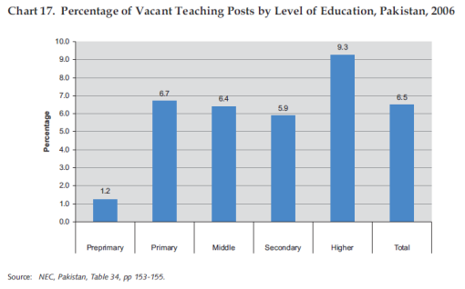

Rural areas show much higher vacancy rates than urban centers, ranging from 10 percentage points at the higher secondary level to one percentage point at the preprimary level. A key issue in the future will be how to attract qualified teachers to serve in rural areas. Vacancy rates for primary education will be a key factor in efforts to achieve the EFA goal of (good quality) universal primary education.

Vacancy rates in the Punjab are higher than in other provinces, at all levels of education except primary, where Sindh and ICT have relatively more vacancies. The vacancy rate for higher secondary teaching posts in the Punjab is 13%. Over 8% of primary teaching positions in Sindh and ICT are vacant. However, FATA, FANA and AJK all report lower vacancy rates.

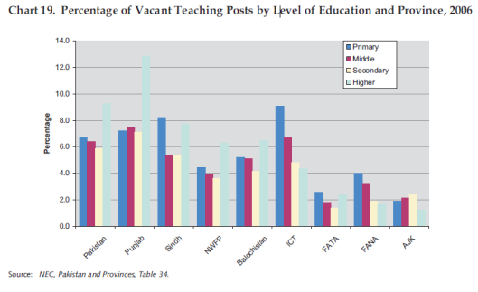

BIBLEOGRAPHY:

1. Government of Pakistan, Ministry of Education, Academy of Education Planning and
Management, Statistics Division, Federal Bureau of Statistics, “National Education
Census 2005 Pakistan”

1.1 Ibid., “National Education Census 2005 Punjab”
1.2 Ibid., “National Education Census 2005 Sindh”
1.3 Ibid., “National Education Census 2005 NWFP”
1.4 Ibid., “National Education Census 2005 Balochistan”
1.5 Ibid., “National Education Census 2005 ICT”
1.6 Ibid., “National Education Census 2005 FATA”
1.7 Ibid., “National Education Census 2005 FANA”
1.8 Ibid., “National Education Census 2005 AJK”
1.9 Ibid., “National Education Census Highlights”
1.10 Ibid., “National Education Census District Education Reports”
1.11 Ibid., “National Education Census District Reports, Punjab”
1.12 Ibid., “National Education Census District Reports, AJK”

2. Government of Pakistan, Ministry of Education, “Financing of Secondary, Higher
Secondary and College Education”

3. Ministry of Education, Academy of Education Planning and Management, “Pakistan
Education Statistics, 2004-2005”

3.1 Ibid., “Pakistan Education Statistics, 2005-2006” AEPAM/NEMIS Statistics study
3.1 Ibid., “Pakistan Education Statistics”

4. Shami, Shah, Ahmad, “National Education Core Indicators,” Academy of Educational
Planning and Management, Islamabad

5. Shami, Butt, Mushtaq, “EFA Indicators (NEC 2005-06) Draft,” Academy of Education
Planning and Management

